Centrifuge for Microplates--- HPC2500
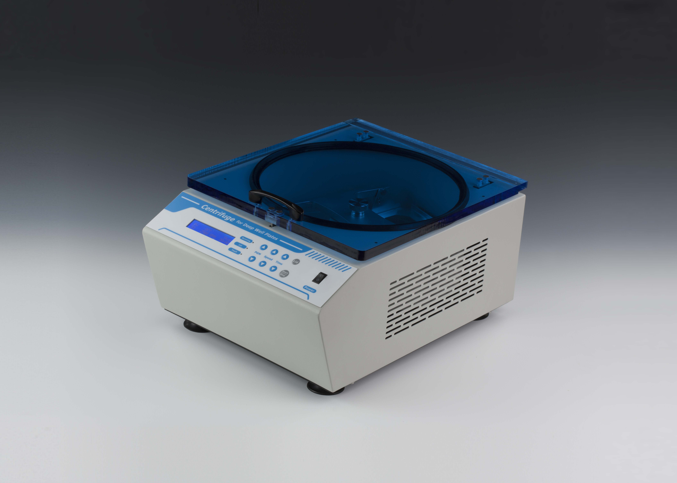
Description:
Centrifuge for Microplates combines microprocessor control technology and automatic imbalance detection technology. It is suitable for a wide range of analytical applications including biochemistry, molecular biology, immunoenzyme analysis and general laboratory centrifugation.

Features:
- RPM/RCF changeable.
- LCD display, DC brushless motor, controlled by microprocessor.
- Low noise, free from carbon contamination.
- Balance test and unbalance alarm.
- Electronic lock, exceeding speed protect, system self test.
- Five programs for speed and time setting.
- Support multi points running function.
- Automatic running function.
- Auto resume to run after power failure.

Parameters:
Model | HPC2500
Speed range | 500~2500rpm
RCF range | 32~797g
Timing range | 1min~30min
Noise | ≤55db(A)
Multi-points running | Yes(Max. 5points)
Multi cycle | Yes(Max. 99times)
Auto resume to run | Yes
Automatic unbalance detection | Yes
Capacity | 2pcs Microplates or Deep-well plates
Power | 150W
Voltage | AC220V or AC110V/50-60Hz
Dimension(mm) | 463x340x248
Weight(kg) | 15.7

